Purpose / Vision

# CUSTOMER SEGMENT(S) CS 6. CUSTOMER CONSTRAINTS CC 5. AVAILABLE SOLUTIONS AS

It is useful for

* + **Children to understand the digits**
  + **Person who are at industry side for recogni**z**ing various handwriting digits.**
  + **People working in bank, post offices**
* **Time**
* **Accuracy**
* **Ease to access**
* **Imperfect findings**
* **In past they get trouble in finding handwritten digits**
* U**sing this system, they can resolve this type of problems**
* **Pros of this system is** q**uick recognition and**
* **Accurate prediction**
* **Cons are network connection is mandatory for using this system**
* F**or using this system** K**nowledge about the system is re**q**uired**

# JOBS-TO-BE-DONE / PROBLEMS J&P 9. PROBLEM ROOT CAUSE RC 7. BEHAVIOUR BE

There are different types of handwriting are in world. Each and every handwriting has its own characteristics and uniqueness. Its difficult to understand the different people’s handwriting digit.

* **Not everyone can understand everyone**’**s handwriting**
* **The handwriting is differed from person to person**
* **So, it is difficult to recogni**z**e the digits**
* **To solve this problem this system has developed**

To address the problem, they can take a snap of the handwritten digit and upload it in the software

# TRIGGERS TR 10. YOUR SOLUTION SL 8. CHANNELS of BEHAVIOUR CH

* + B**y word of mouth**
  + **Good user experience**

# EMOTIONS: BEFORE / AFTER EM

* + **It is a** q**uite irritating and frustrating while manually convert the**

handwritten digits

* + B**y using our system, user can save the time and reduce the error occur on recognition**
* **A novel method for handwritten digit recognition system helps in recogni**z**ing the handwritten digits that uses** M**NIST dataset for training the model.**
* **The model gets the image of the handwritten digits and recogni**z**es the handwritten digits.**
* **CNN algorithm is used over the** M**NIST dataset to recogni**z**e the handwritten digits.**
  1. **ONLINE**

In online they can upload the handwritten picture and yield output

* 1. **OFFLINE**

In offline they can ask their neighbors to scribble the digits to find them

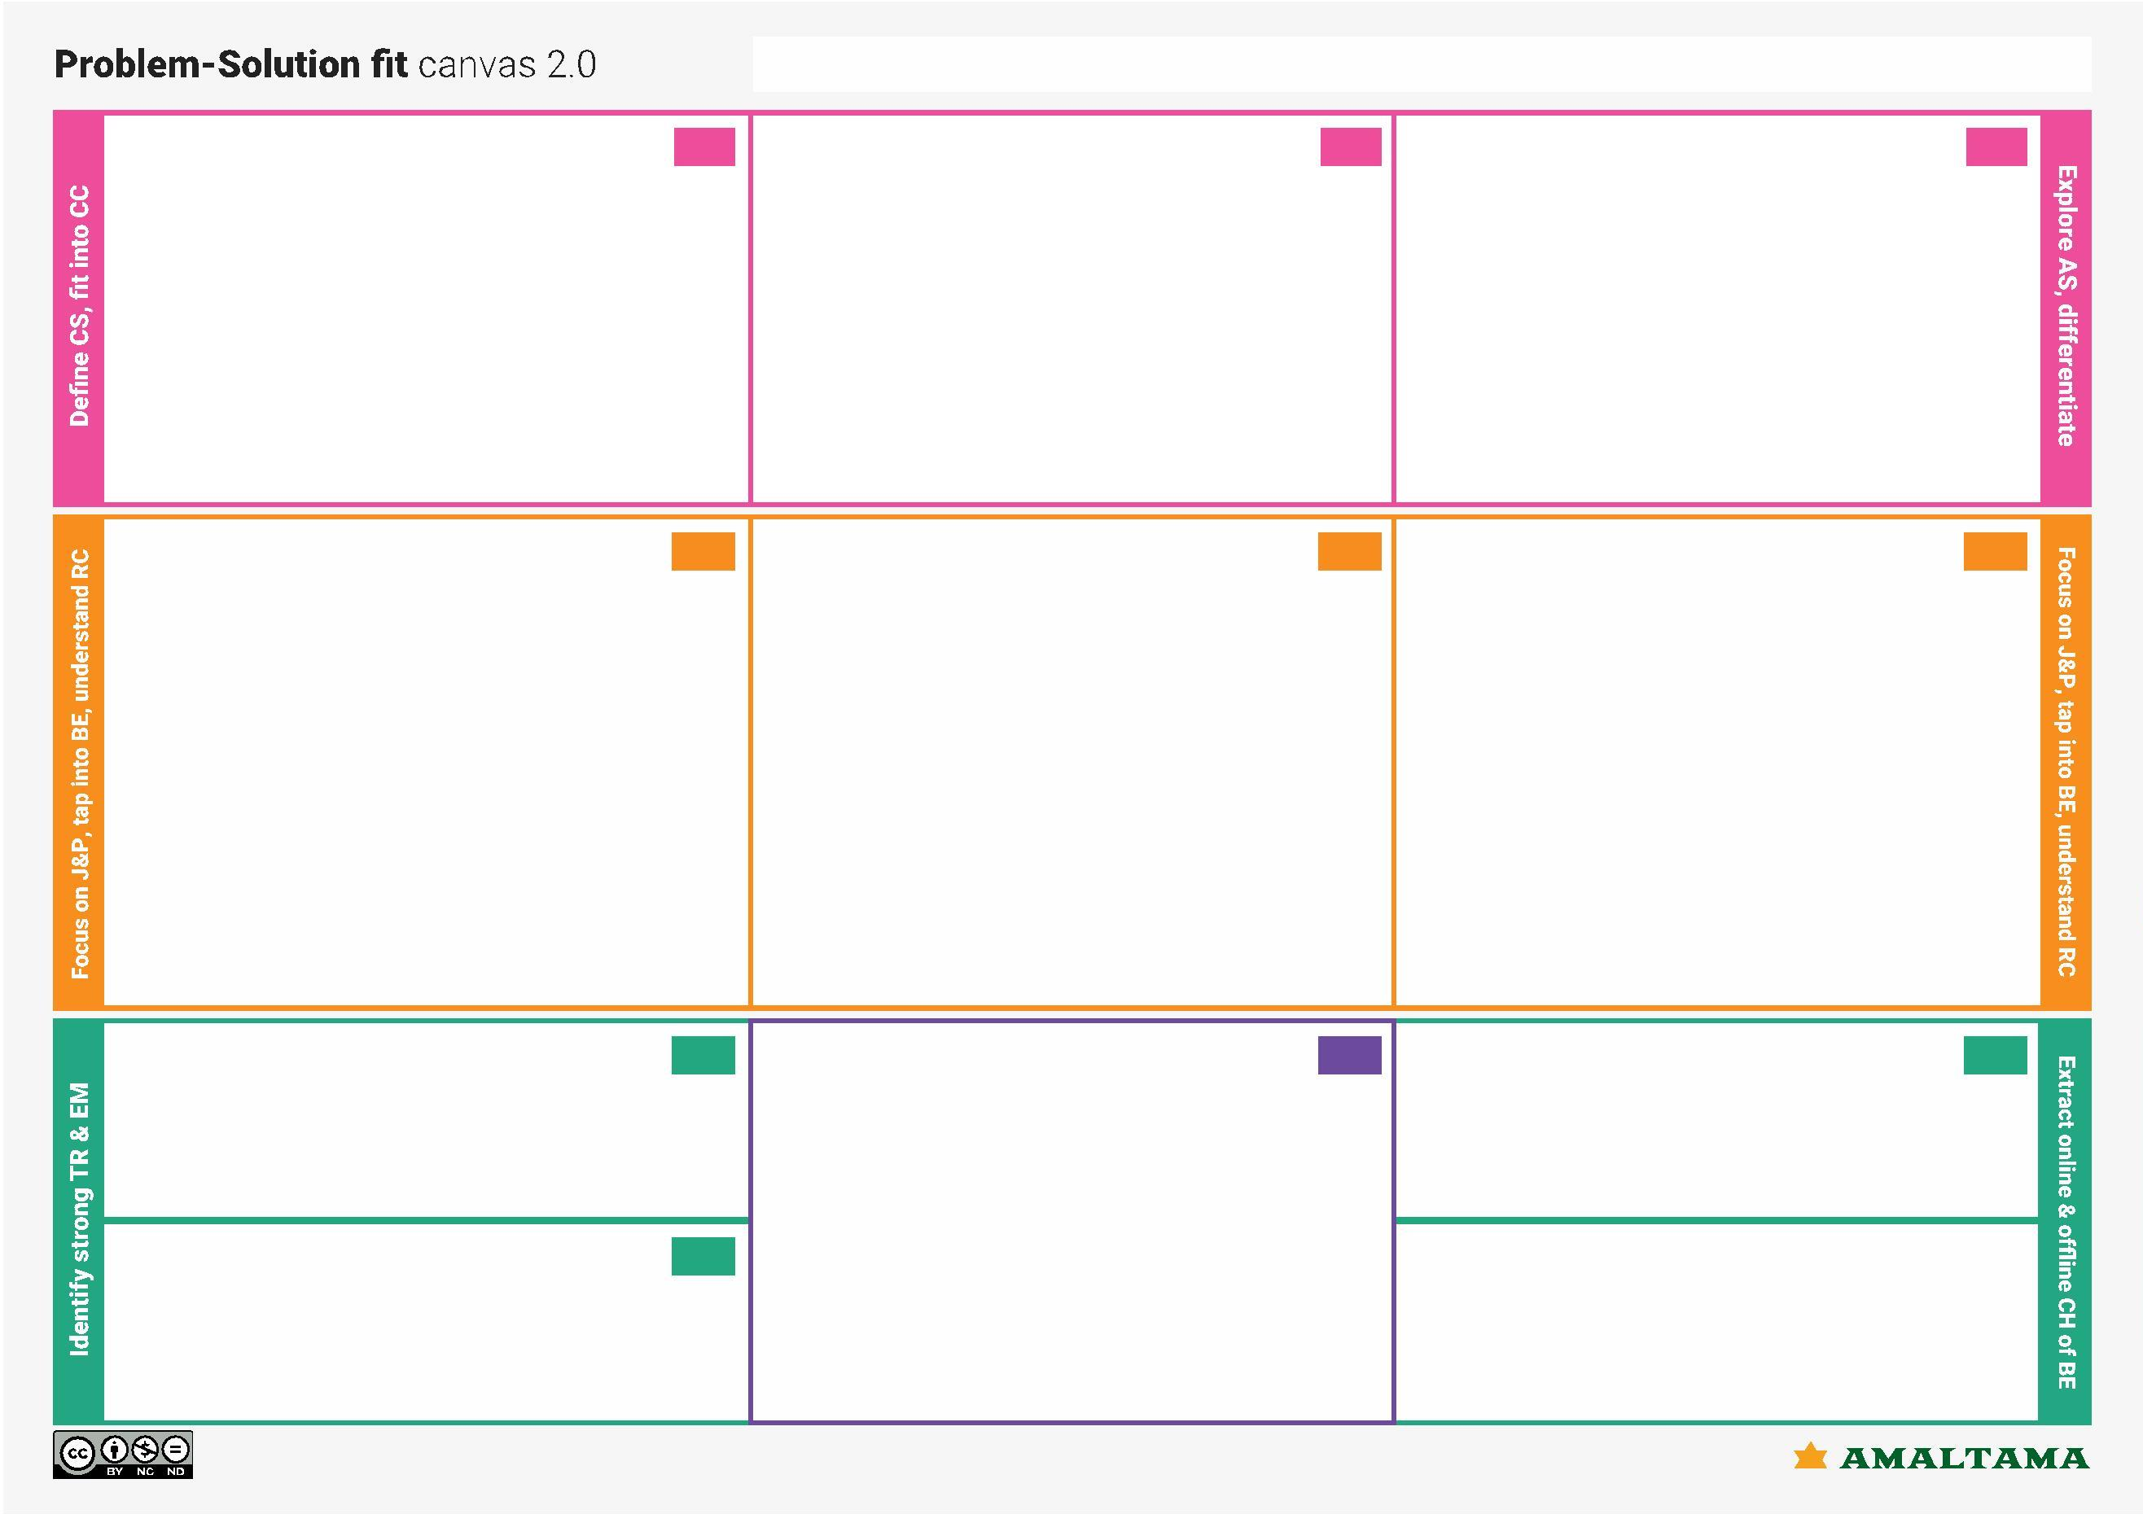

**Problem-Solution it canvas is licensed under a Creative Commons Attribution-NonCommercial-NoDerivatives 4.0 license Created by Daria Nepriakhina / Amaltama.com**